Ansible MERNSTACK Project

What is the mernstack?

* Package or component use in web development using end-to-end JavaScript (frontend , backend )

MERN :

* MongoDB
* Express JS
* React JS
* Node JS

1. Prepare environment Using Multipass:

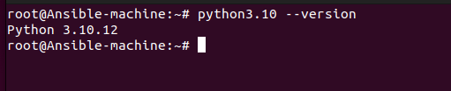

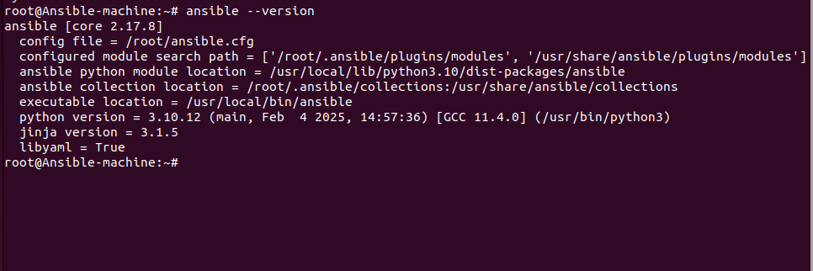

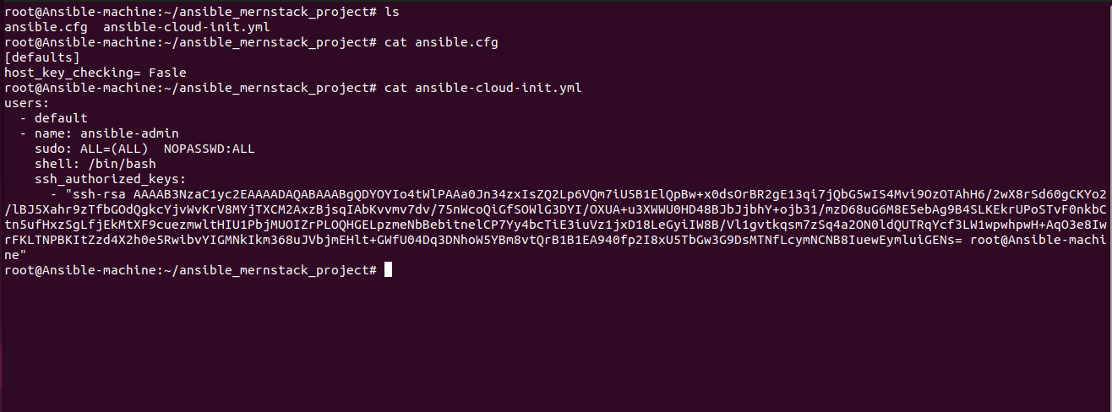

// use a cloud-init.yml to establish reachability between ansible node and targets

// multipass :

* Web machine (provision with high resources )



* Db server machine :



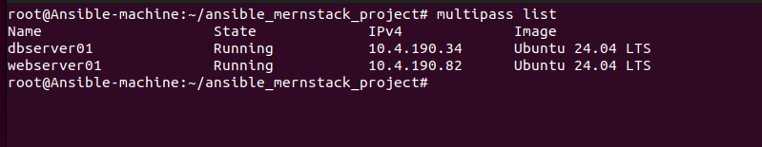

1. Create inventory file (for targets)

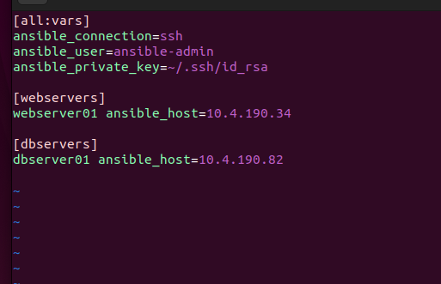

1. Create role for common packages

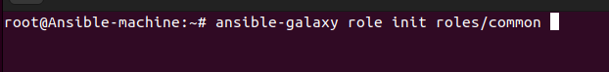

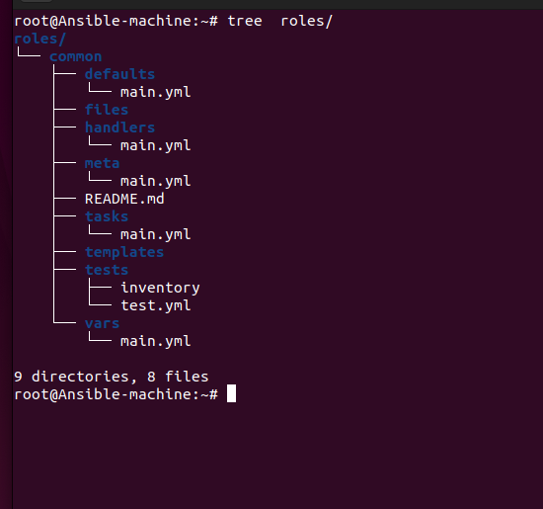

1. Define variables

* Define default variable defaults/main.yml (can override)

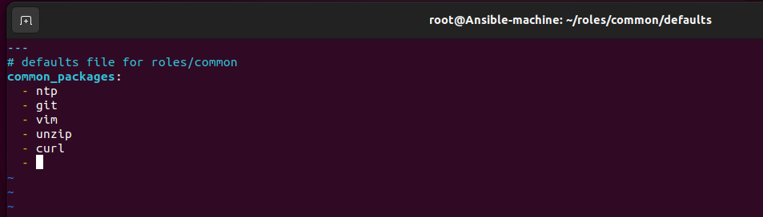

* under make a Directory named group_vars

group_vars : put in it variables refer to groups in inventory file

* Do a file name_of_group_in_inventory.yml
* Override the variables in default/main.yml

Note: can search about variable precedence in ansible

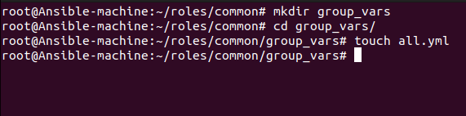

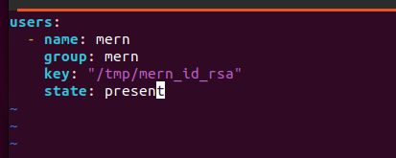

1. Define Tasks
2. update all packages and install common packages

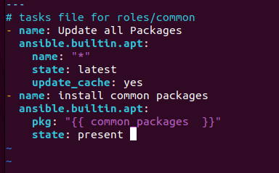

Note :

Pkg with apt : take a list of packages

1. create key pair on local machine to user

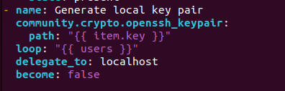

1. add user on remote machine

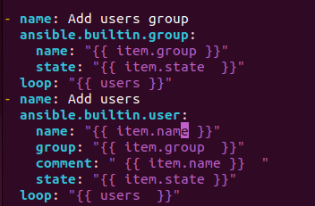

1. send public key to remote machine

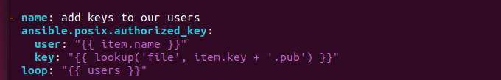

// using lookup plugin to get file , read content of file and put in key:

6- create playbook to call role and other roles will create it

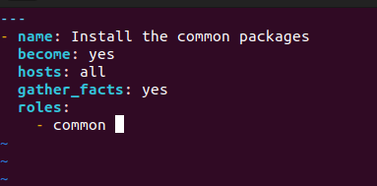

* Running playbook :

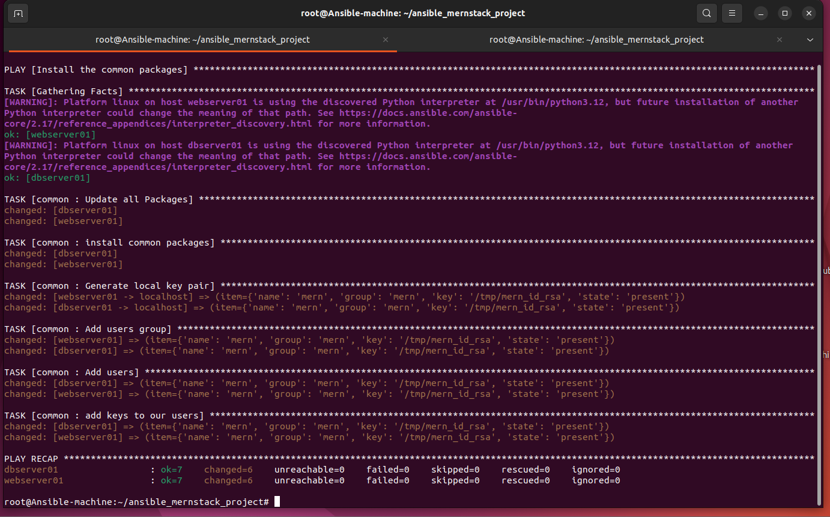

* Verify :

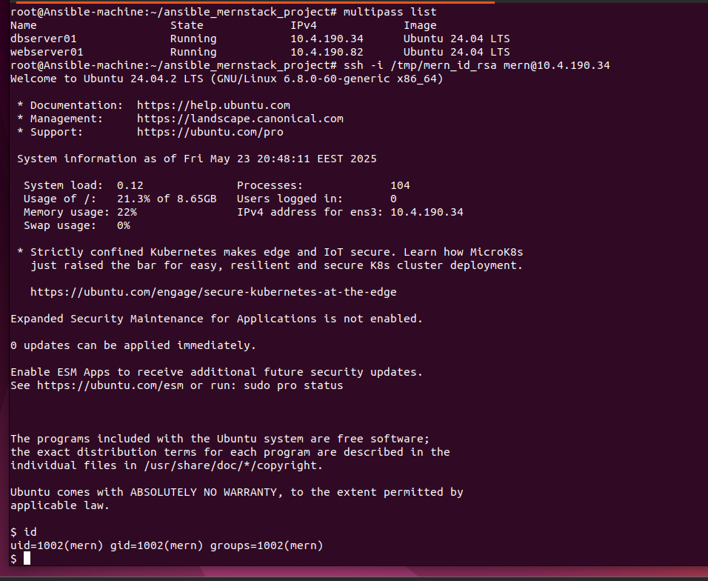

Web server Role

(ExpressJS , ReactJS , NodeJS )

1. Create variables

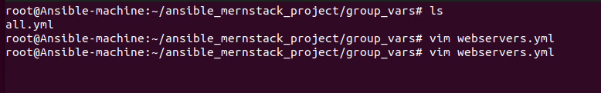

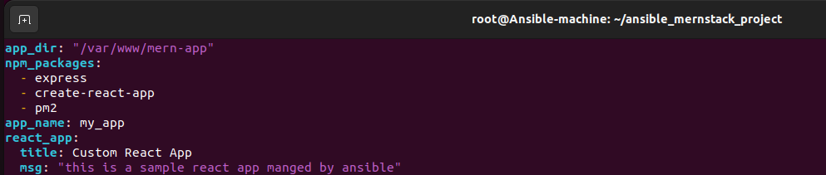

// npm : package manager for JS

1. Create role

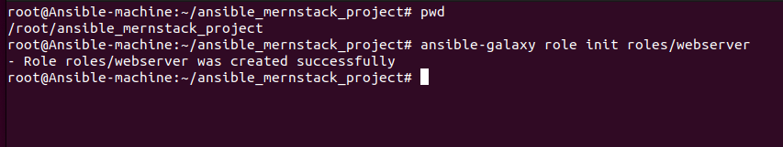

* Add variable in default : 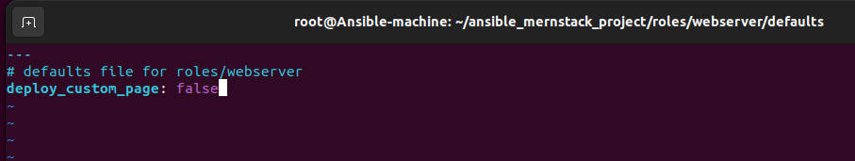
* Create templating engine 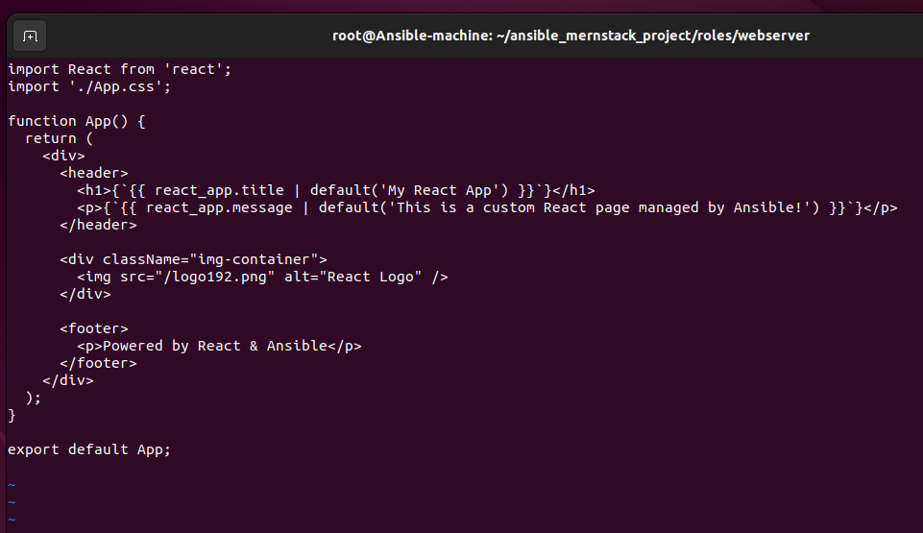
* Create Static file (fixed not have a variables ) to css



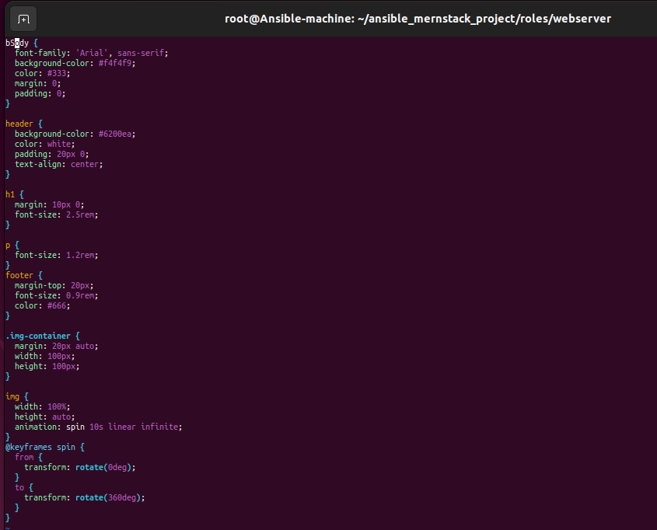

* Create tasks 1

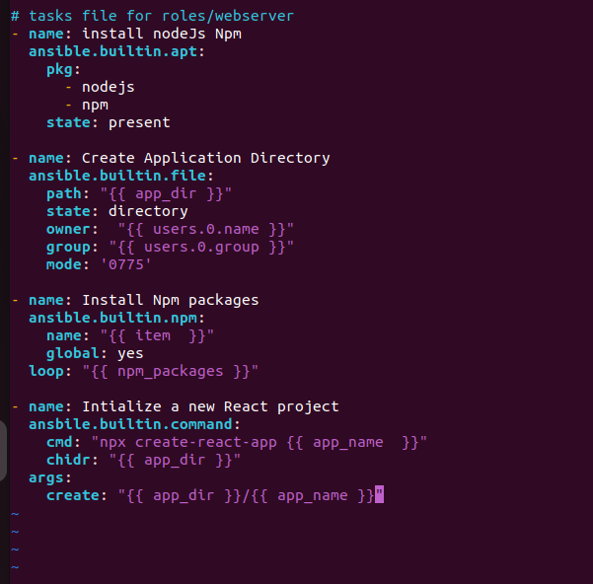

Note :

* user.0.name -> the first user in list
* Global: yes in npm to install to per machine not per project
* Solve idempotent here with args , to create a directory to first time and if run again skipped
* Complete tasks

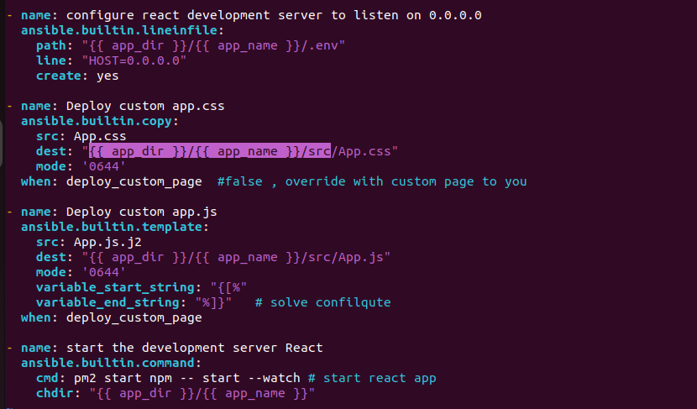

Note :

To solve confilqute in this line of template (only ansible with React js )

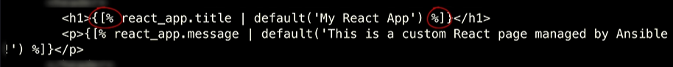

* Playbook :

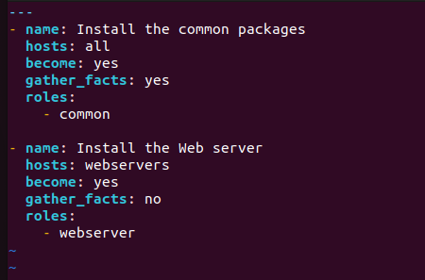

Run :

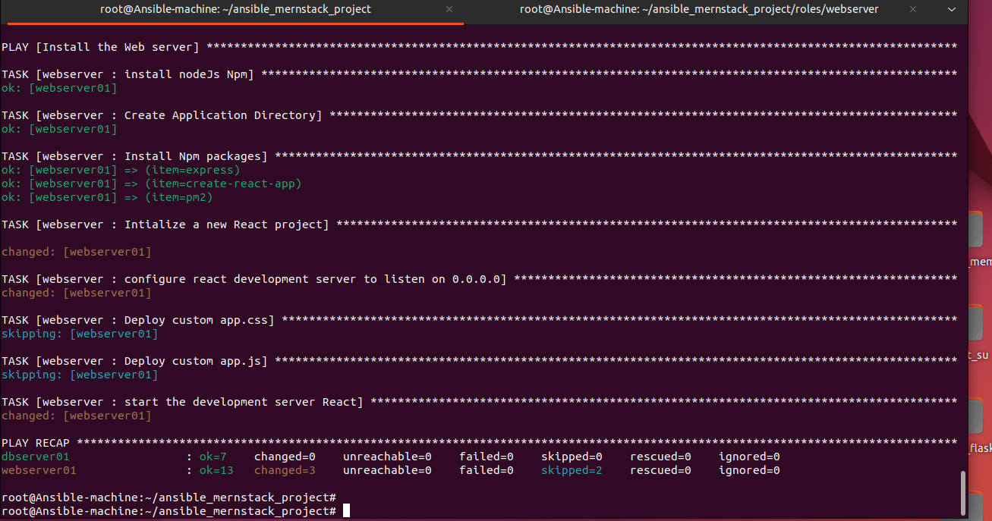

Verify :

Note:

* In [ multipass ] not open only port 22 ssh
* Access another port through ssh [ssh-tunneling ]

# ssh -fN -L 0.0.0.0:3000:localhost:3000 [ansible-admin@10.4.190.82](mailto:ansible-admin@10.4.190.82)

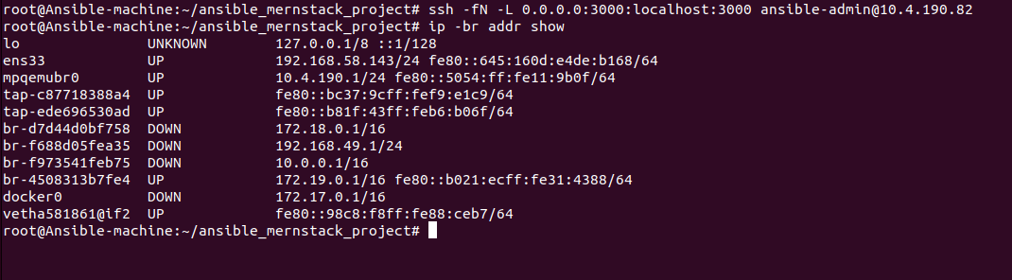

Test :

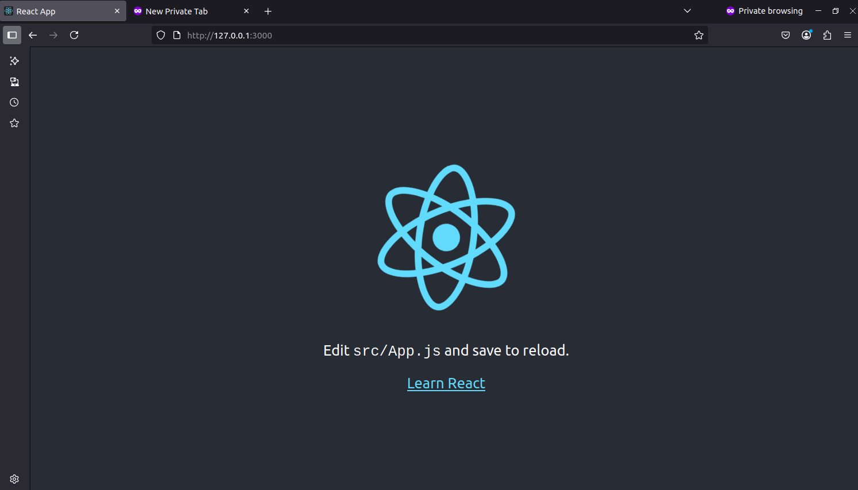

* Add my own app : add group_vars/webserver.yml
* Override value to defaults

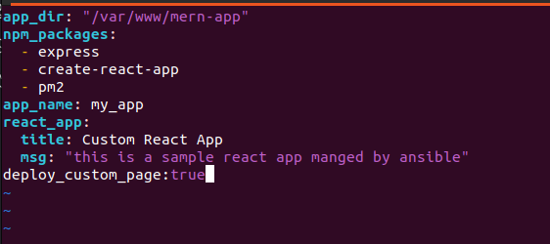

* Run again

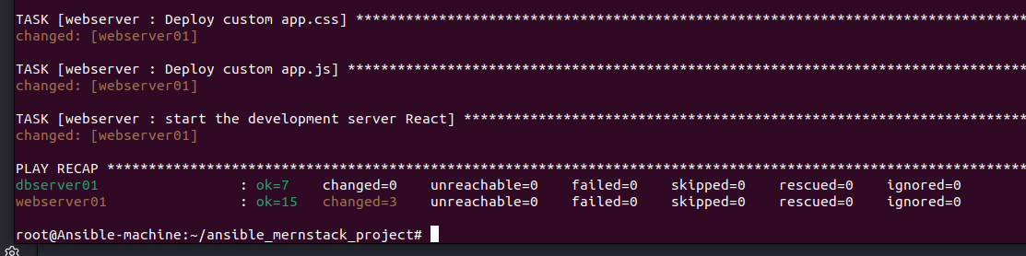

* Test

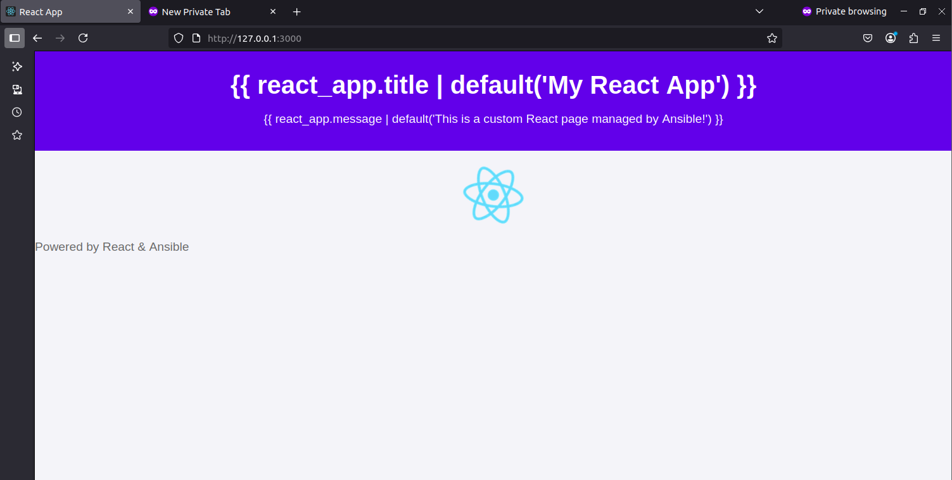

Database Role

MongoDB (NoSQL DB)

* Create role :

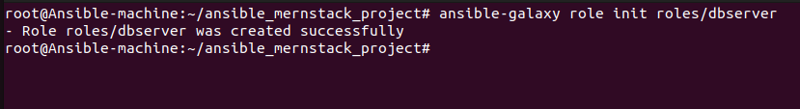

* Default variables

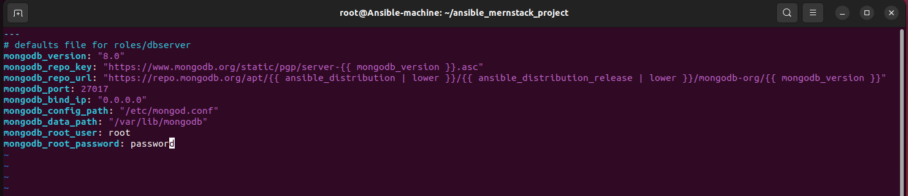

* Create handler

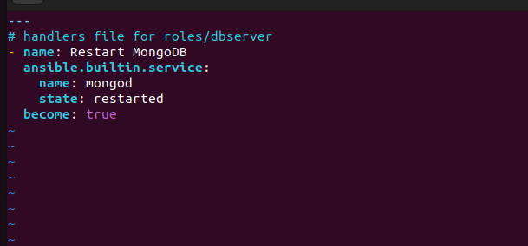

* Create template mongod.conf.j2

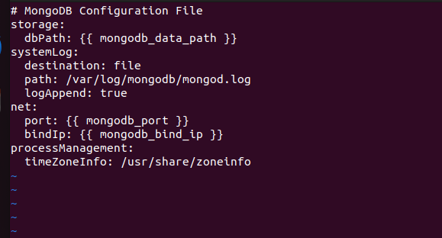

* Auth template mongoshsrc.js.j2

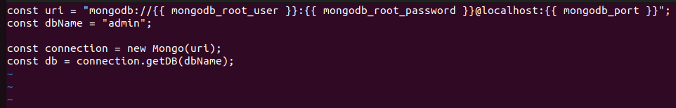

* Tasks : divide tasks (installation)



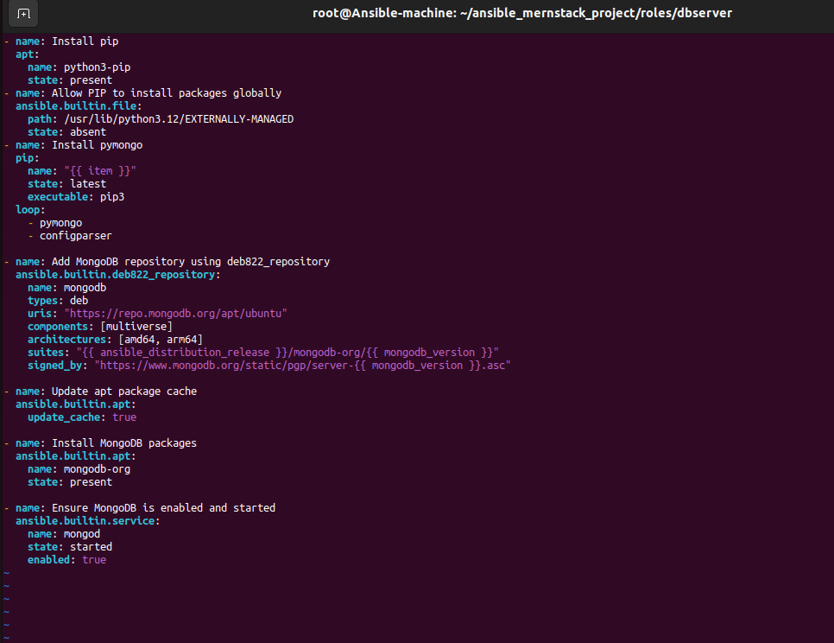

* Task 2 : configuration



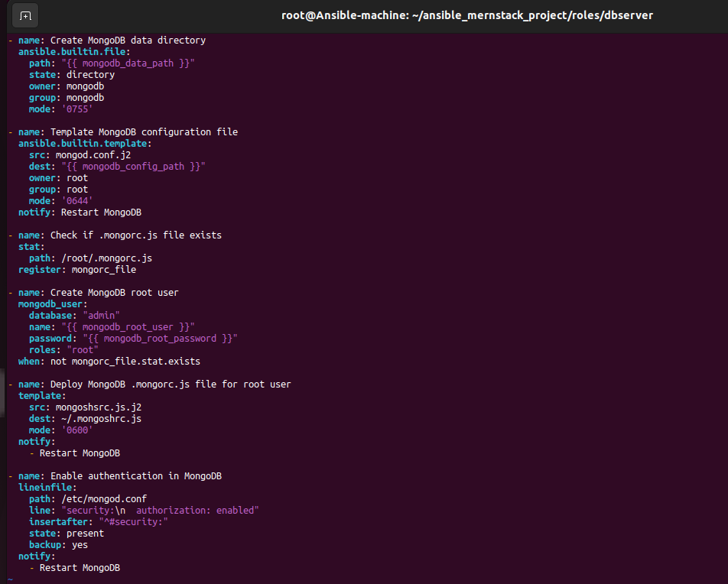

* Include tasks to main.yml :



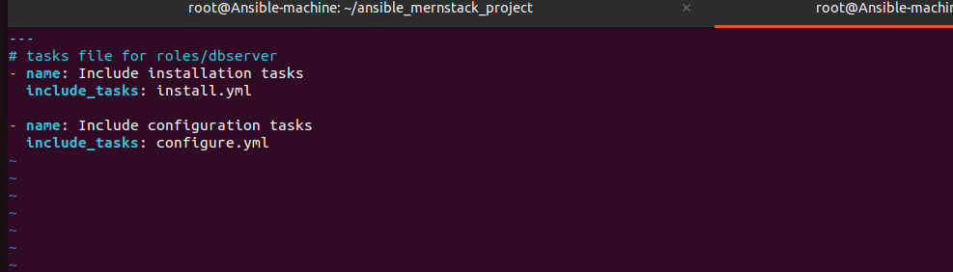

* Configure playbook

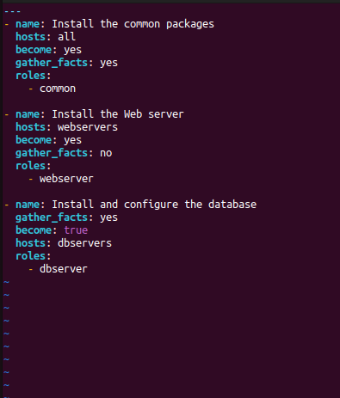

* Run playbook :



* Verify :

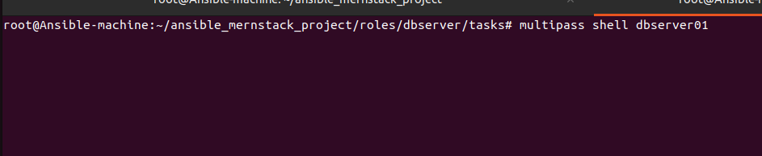

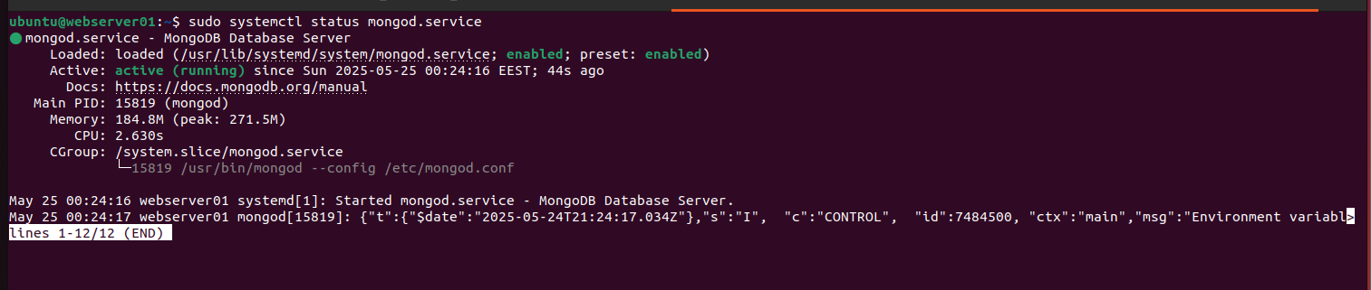

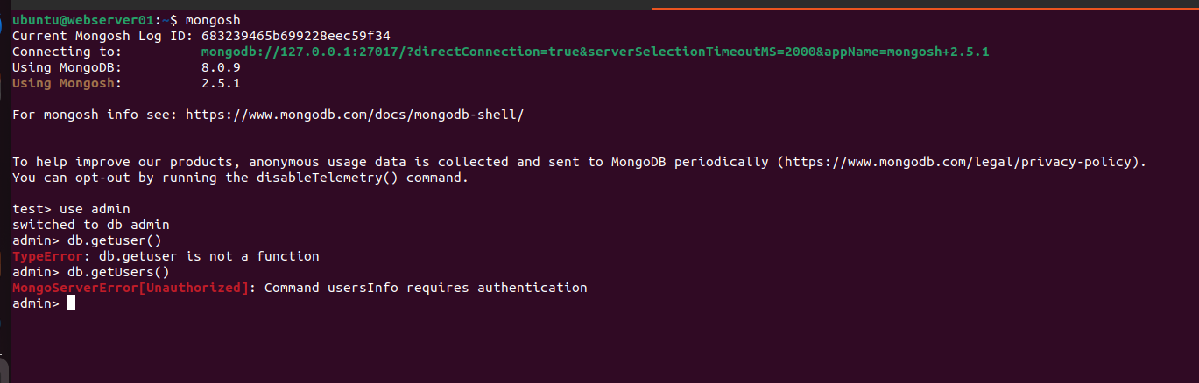

// Authentication using file

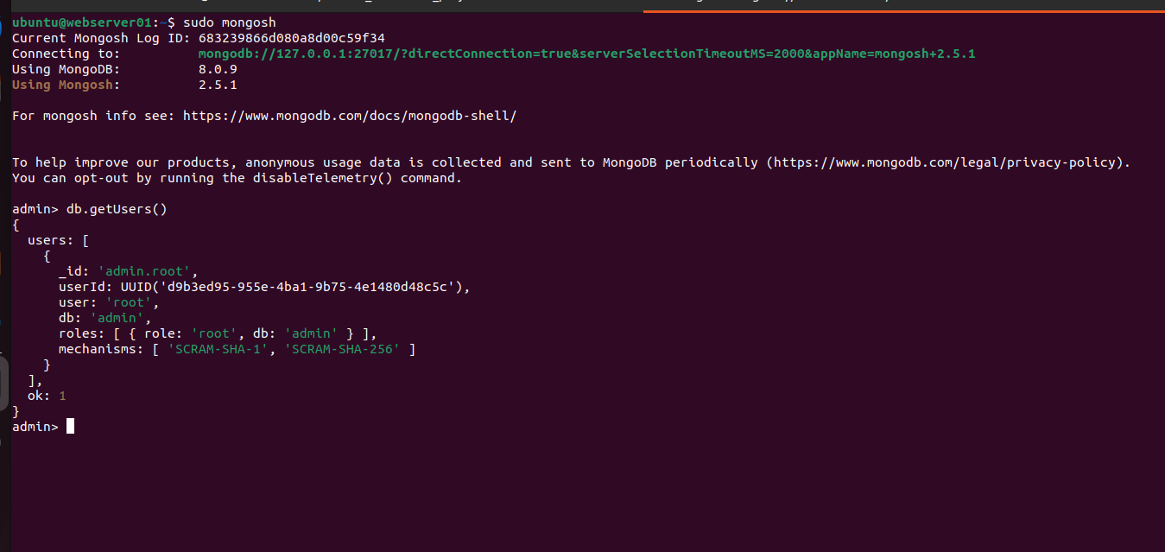

##############Done ✔✔✔############